Calculus 2 Lecture 8.6: Numerical Integration With Trapezoidal and Simpson's Rule

The Trapezoidal Rule

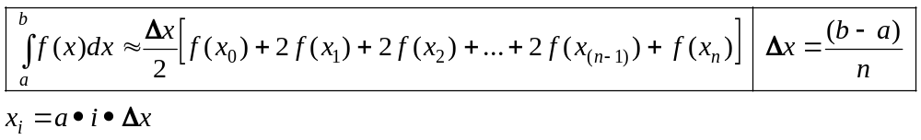,

Example
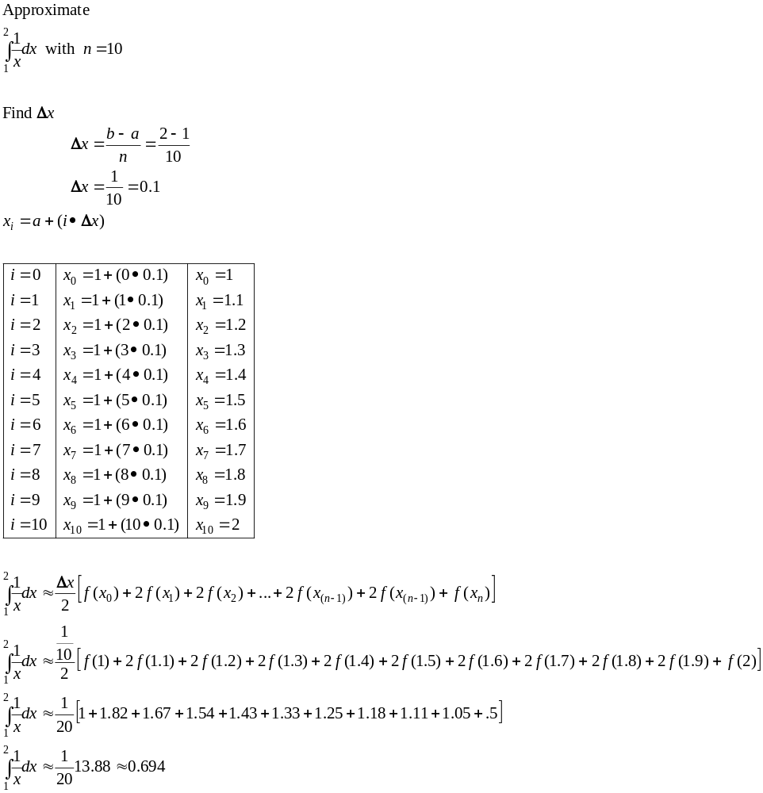

The Simpsons Rule
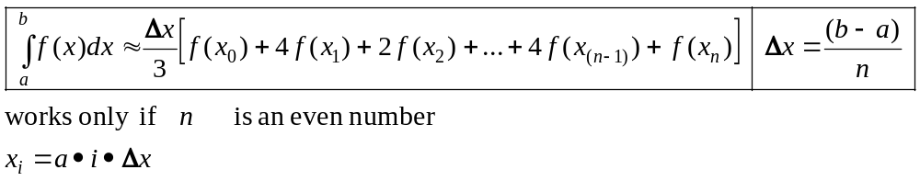

Example
